**E-LEARNING BIZAGI COURSE**

**PROCESS MODELING**



**Adam Arthur Faizal**

**M3119001**

**TI A**

**PROGRAM STUDI TEKNIK INFORMATIKA**

**SEKOLAH VOKASI**

**UNIVERSITAS SEBELAS MARET**

**SURAKARTA**

**2020**

# Basic Standard

# Basic Concepts

# Activity

# Gateways

# Events

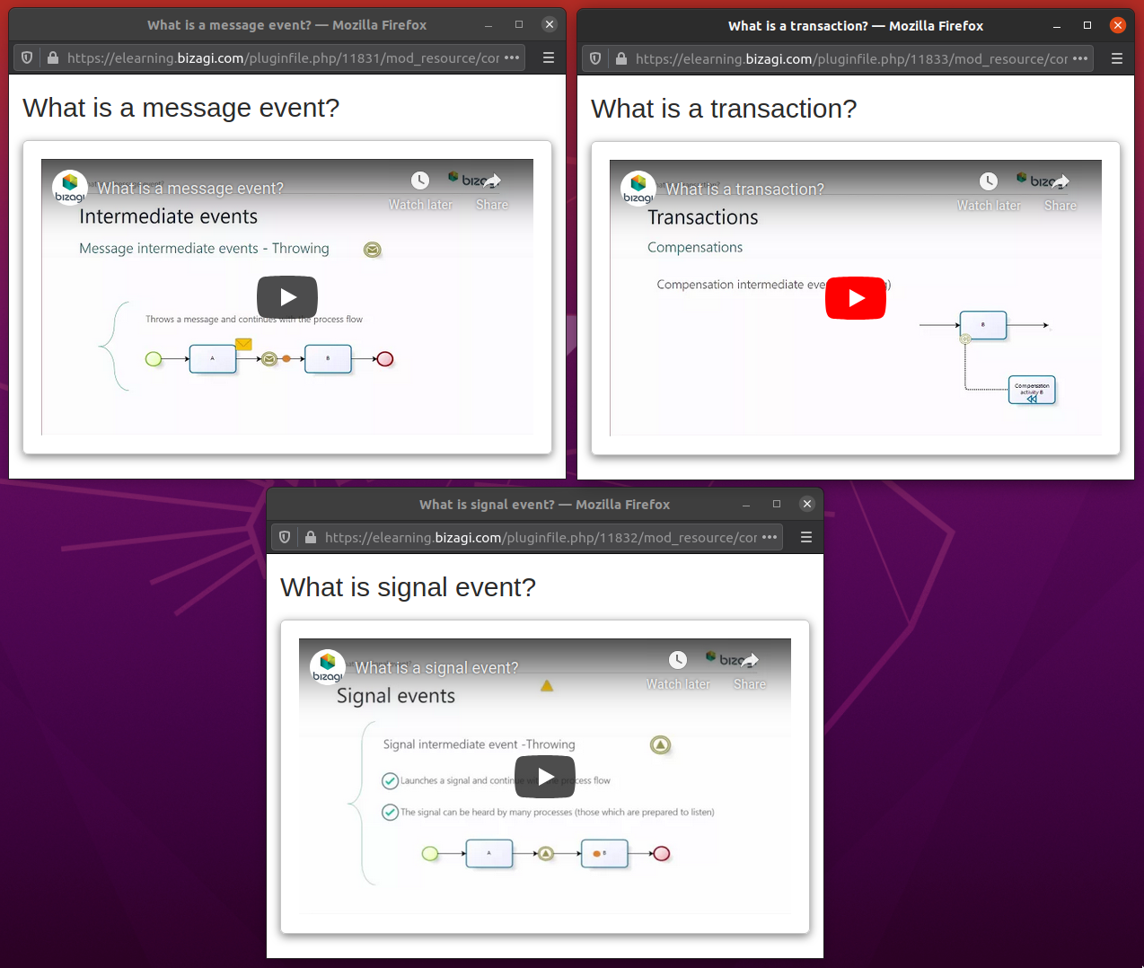

# Automation

